King Edward VII College

Change management plan v1.7.0

### Data：25/4/2022

### Organised by

### Vivi

##### Change management plan content：

##### Description of the current ICT system in place

##### A rationale for the changes required to the ICT system

##### Industry benchmarks to be achieved for the ICT system

##### Impact of changes

##### Change management activities, responsibilities and timelines.

Description of the current ICT system in place

The currently used ICT System Learning and Assessment Materials sharing system is conducted via email.Students will receive study and assessment materials one week before they start a new course to prepare and understand the course.  And send the assignment to the trainer before the deadline  .Students can also send questions to their teachers via email from within the system.However, this system for sending and sorting data operation is tedious and single, it is difficult to track the real-time situation and lack of a centralized database resulting in different versions of the data, which also increases the workload of students and teachers, but also prone to query the wrong version of the data

##### A rationale for the changes required to the ICT system

With the increase of time and number of users of the ICT, the system no longer meets the needs and faces some challenges, which must also be overcome for the convenience of users. To overcome these challenges, an ICT system change management plan must be developed.

### Challenges：

* There is a lot of administrative effort to to collate and send out materials at the beginning of each unit, especially given that there are hundreds of units across a multitude of courses.
* It is difficult to track receipt of materials and submission of assessments.
* There is confusion about versions as there is no central repository for materials.
* Tracking issues

##### Industry benchmarks to be achieved for the ICT system

1. The network speed is 12Mbps when transferring or accepting files
2. Different types of devices are required to be compatible with modified systems, such as tablets, mobile phones, and laptops
3. Ability to store data and materials without limit

##### Impact of changes

Use appropriate funds to upgrade the ICT system will make it easier for students and teachers to save effort to use the system, and the wrong version of the information will not be added after the central repository.Online delivery of homework not only makes communication more efficient between teachers and students, but also makes them closer.

##### Change management activities, responsibilities and timelines.

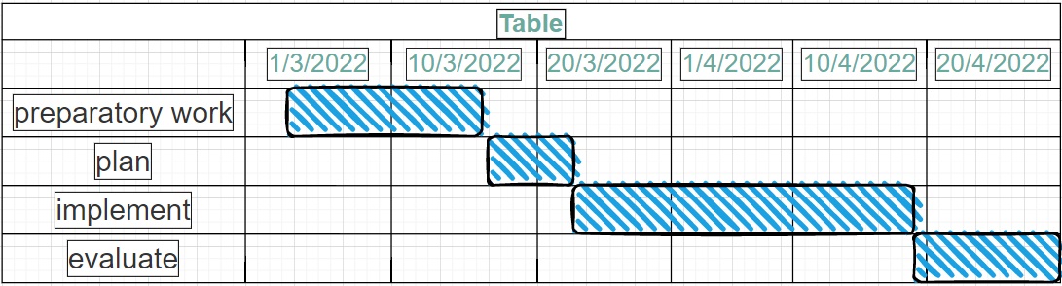

Preparation:

* Identify why change is required and what outcomes are to be achieved.
* Evaluate risks and benefits.
* Estimate costs.

Planning:

* Decide how change will be implemented.
* Determine who the stakeholders will be.
* Write a Change Management Plan.
* Consult with stakeholders.
* Adjust Change Management Plan when relevant.

Implementation:

* Complete tasks as per the change management plan.
* Ensure that all management and staff are trained to adapt to changes being made.
* Support management and staff to adopt changes positively.
* Monitor progress and resolve any issues that arise.
* Manage costs.

Evaluate:

* Assess whether change has been incorporated into business as usual.
* Evaluate the success of change management.
* Evaluate process and refine documentation as required.